SER Patient Information Sheet: Nuclear Medicine

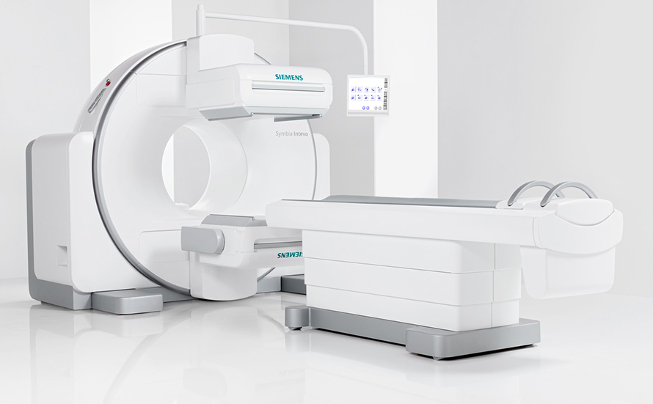
Nuclear Medicine is a subspecialty of radiology which involves the use of radioactive medication (radiopharmaceuticals) to diagnose and sometimes treat disease. These radioactive materials are usually injected into a vein, but are sometimes swallowed or inhaled.

Single photon emission computed tomography (SPECT) images are obtained following an injection of a radiopharmaceutical which sticks to specific areas in the body, depending on what radiopharmaceutical is used and the type of scan being performed. The radiopharmaceutical is detected by the gamma camera. The “head” of the camera rotate over a 360-degree arc around the patient, allowing for reconstruction of images in three dimensions.

A SPECT-CT system also has a CT scanner incorporated into the machine. CT images are also obtained while you lie on the bed, which may move into the gantry, or “donut” shaped opening whilst acquiring the images. The similarity in the image processing allows these 2 sets of images to be merged. The combined study allows information about function from the nuclear medicine scan to be overlaid with how the body’s anatomical structure “looks” in the CT study, and more clearly identify problems and location.

Nuclear Medicine tests and procedures can include:
- SPECT-CT Scan; Cerebral Perfusion Study; Iodine-131 Therapy;
- MIBG Scan; Bone Scan; Cardiac Stress Test;
- DMSA Scan; Gated Blood Pool Scan;
- Renal Scan; Thyroid Scan;
- Octreotide Scan; Parathyroid MIBI Scan;
- VQ Scan; Whole body MIBI myeloma

ph: (02) 4429 2333 | fax: (02) 4421 7710 | email: wcomp@wlpradiology.com.a | www.southeastradiology.com.au
Who does the Nuclear Medicine study?
A Radiologist or Physician (specialist doctor) who has completed additional and specific training in nuclear medicine will oversee the study. They will usually be accompanied by a nuclear medicine technician, who has obtained a university degree
in nuclear medicine. This qualifies them to:
•measure and use radiopharmaceuticals
• give injections and take blood samples
• use nuclear medicine gamma cameras
• use computers to process and analyse nuclear medicine studies
• understand diseases investigated or treated by nuclear medicine.

What is a radiopharmaceutical?
A radiopharmaceutical is a medication used in nuclear medicine that has a radioactive part and a pharmaceutical part. The radioactive part is sometimes referred to as a radioactive label or a radioactive tracer. The radioactive part is an unstable
element (radioisotope) that gives off energy as it decays (disintegrates or breaks down) and changes to a different element or energy state.

The actual amount of the radioactive substance given for most imaging tests is usually very small, approximately millionths of a gram. The dose of ionising radiation received by a patient having a nuclear medicine test can be very low or moderate and the dose varies between different types of studies.

The ionising radiation is like that received from computed tomography (CT) imaging. The body does not feel the ionising radiation, and it does not make you ‘warmer’ or ‘glow in the dark’. The number of times the nuclear medicine camera takes images does not determine the dose of ionising radiation received during a nuclear
medicine test. It is determined by the type and amount of radiopharmaceutical injected, the half-life of the radioisotope and how quickly this is eliminated from the body in urine, stools or breath.

The half-life is the time taken for half of the radioactive atoms to decay or change their energy state. For most radioisotopes used in nuclear medicine, this half-life
is measured in hours, so after a day or so there is very little radioactivity remaining.
The pharmaceutical part can be a few atoms or a complex molecule that helps take the radioactive part to the area of the body being studied. It is mostly the choice of the pharmaceutical part that determines where the radiopharmaceutical will go in the body and what organ system will be shown.

What is a Gamma Camera?
A gamma camera is a machine that is able to detect and make images from the very small amounts of ionising radiation emitted from patients having a nuclear medicine study.

The gamma camera usually has a table, often narrow, on which the patient lies. The images are taken using the camera ‘head’. There are no unusual sensations associated with having images taken with a gamma camera and the machine makes no noise.

How is Nuclear Medicine different from X-ray and CT examinations?

During a normal X-ray or CT examination, an image is formed from the ‘shadow’ created by the body as it is positioned between the X-ray machine (source of the X-ray beam) and the X-ray detector. The body stops some, but not all the X-rays and the patient is not made radioactive by the X-rays.

In nuclear medicine studies, the radiopharmaceutical given to the patient makes them, and the organ system or body part being studied, radioactive for a short time. This ionising radiation (usually a gamma ray) is emitted or released from the body, and can be detected and measured using a nuclear medicine gamma camera.

All living things contain some radioisotopes (such as carbon 14 and potassium 40) and a nuclear medicine study will make them ‘more radioactive than normal’ for a short time – hours or days.

An X-ray or CT image is formed from ionising radiation (X-rays) that passes through the body, but does not arise from the body; whereas a nuclear medicine image is formed from the ionising radiation (usually gamma rays) emitted from within
the body. A gamma ray has similar properties to an X-ray, but it arises from the nucleus of an atom, whereas an X-ray arises from the electron shell of an atom.

Another way that nuclear medicine is different from X-ray and CT examinations is that an X-ray study shows what something looks like. This gives indirect information about how it is working: normally, abnormally, diseased, injured and so on.
In nuclear medicine studies, the radiopharmaceutical usually only goes to the part of the body or organ system if it has some function and so shows how it is working. Nuclear medicine and X-ray tests are often complementary, providing different
information that together make a diagnosis more certain.

What are the risks of a Nuclear Medicine Study?

There are minimal risks in having a nuclear medicine study. These are allergic reactions and radiation risk.

Allergic reactions have been described, but are very rare and almost always minor. If you have ever had an allergic reaction to a medication you should tell our staff, before you have the radiopharmaceutical. In most cases, there will be no reason
to cancel the study, but you might be observed more closely during the test to ensure any reaction is treated appropriately.

Radiation risk

For children and adults

The test involves a small dose of radiation from the radiopharmaceutical medication. The dose is similar to CT and fluoroscopy procedures. As for all imaging studies
involving ionising radiation, it is important that careful consideration is given to carrying out an alternative test that does not involve ionising radiation (such as ultrasound or magnetic resonance imaging (MRI)).

The radiation dose received from bone scans and renal scans is minimised by encouraging the patient to drink more clear fluid after the test. Nuclear medicine studies are used in children, and the dose of the radiopharmaceutical given is adjusted to the patient’s weight.

For pregnant women
Imaging of pregnant women with ionising radiation is generally avoided if possible. When it is required, it is usually carried out after discussion with the supervising nuclear medicine specialist. Pregnant women do sometimes have nuclear
medicine studies, but this is usually only for blood clots in the lungs (pulmonary emboli (PE)). The radiation dose and associated risks of a lung scan to the patient and foetus (unborn child) are small in comparison to the risk of not diagnosing the PE. The dose given is reduced to minimise the radiation dose further.

For breast-feeding patients and/or those having close contact with children
If a person having a nuclear medicine scan is breastfeeding and has close contact with children, there could be unnecessary radiation passed on to the child. Breast-feeding
and close contact might need to be restricted, depending on the radiopharmaceutical used. More specific information and restriction times can be obtained from the nuclear medicine technologist or specialist carrying out the study.

• If breast-feeding needs to be restricted, the milk can be expressed and stored (back of the fridge or frozen) for use after the restriction period.

• If close contact with a child needs to be minimised, it is important to remember the emotional needs of the child. If the child needs a cuddle then this should occur. The child can be touched or kissed, but if another carer is available to comfort the child, then this would be preferable. If the child is happy and/or content, then a safe distance of 2–3 metres should be maintained between the child and the person who received the radiopharmaceutical.

What are the benefits of a Nuclear Medicine Study?

A nuclear medicine study helps your doctor evaluate how a particular area of your body or organ system is working. It can give information about how an injury, disease or infection might be affecting your body. It can also be used to show improvement or deterioration of a known abnormality after any treatment you might have had. Nuclear medicine studies are very good at showing how an organ system is working, and often complement other investigations and imaging studies.

South East Radiology
www.southeastradiology.com.au

