SER Patient Information Sheet: Ultrasound

W 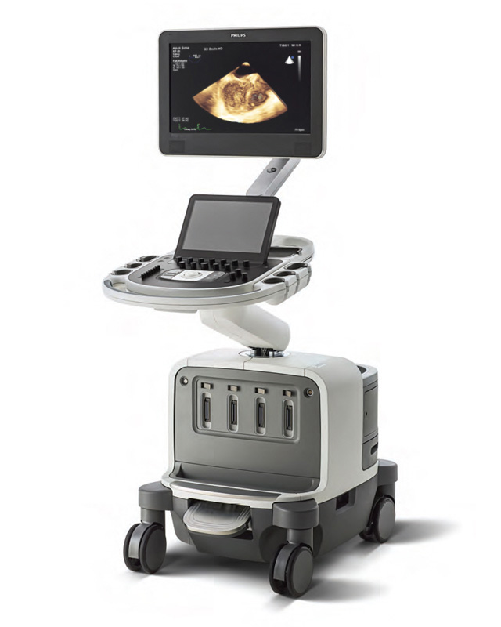 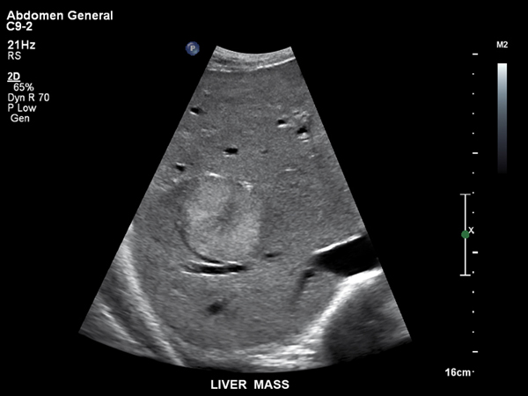

What is Ultrasound?

Ultrasound is the term used for high-frequency soundwaves. Ultrasound examinations use these sound waves to produce a picture or image onto a screen showing the inside of your body.

An ultrasound is carried out by a trained sonographer using a smooth, hand-held device called a transducer that they move across the body with a sliding and rotating action. The transducer transmits the high-frequency sound waves into your body. Different sound waves are reflected from different soft tissue, structures or parts in the body in different ways.

These sound waves are converted to electrical impulses that produce a moving image displayed on a screen. An ultrasound has many advantages. It is painless and does not involve radiation, which means it is very safe. There are no injections unless your doctor has specifically requested one. The high-frequency sound waves ensure images show very high detail, capable of looking at the very tiniest parts of the body. Ultrasound can be carried out while there is movement, so it is excellent for the imaging of babies and children. A health professional will be there with you, and you can communicate any concerns you have.

ph: (02) 4429 2333 | fax: (02) 4421 7710 | email: wcomp@wlpradiology.com.a | www.southeastradiology.com.au

What are the benefits of a Ultrasound?

Ultrasound provides excellent imaging of the soft tissues of the body, and is a safe procedure that does not have the risks associated with imaging that uses radiation (x-rays or Gamma rays)

There are no proven harmful effects of sound waves at the levels used in ultrasound when carried out in a proper clinical setting.

Ultrasound can be used with patient movement, so is ideal for imaging babies and children.

Imaging movement is also very valuable in musculoskeletal (muscle-, bone- and joint-related), gynaecological (women’s health, especially of the reproductive organs) and vascular (blood vessel related) ultrasound. Dynamic imaging (moving pictures) provided by images using ultrasound sound waves gives the opportunity to look at the inside of the body in positions or with movements where there is pain or movement restriction.

Ultrasound is mostly non-invasive, provides accurate imaging tests of the body, is readily available and is relatively inexpensive.

Why would my doctor refer me for an Ultrasound scan?

An ultrasound could be requested for many reasons. You may be most familiar with its use in obstetrics (medical care during pregnancy and childbirth). Ultrasound is ideal to look at the foetus (unborn baby) as it grows throughout the stages of pregnancy. In the first part of pregnancy, it can be used for confirming the age of the foetus and the most likely date of birth, and for screening significant genetic syndromes (eg. Down syndrome). Later in pregnancy, it is used to carefully examine how the foetus is developing, and to ensure the foetus is growing in a healthy manner. An ultrasound obstetric scan is a wonderful opportunity to meet your developing baby.

There are also many other reasons an ultrasound may be requested. For example, it is used to examine organs in the abdomen and other parts of the body. Colour Doppler ultrasound can be used to watch blood flow in any of the arteries or veins throughout the various parts of your body.

High-resolution ultrasound can be used to evaluate the musculoskeletal system (muscle-, bone- and joint-related). Breast ultrasound is an important part of the assessment of any breast lump. Ultrasound can take high-quality images of most parts of your body, which makes it an excellent diagnostic test.

How do I prepare for a Ultrasound?

This will depend on the type of ultrasound that is requested. Listed below are some of the common examinations, with the preparation generally required. When you make a booking with us for an Ultrasound, our staff will provide the relevant preparation for different Ultrasound exams.

All ultrasound examinations:
Read and follow all instructions given to you by our staff when you book for the examination.

Wear clothing that will provide easy access to the area that is being imaged.
Bring any previous radiology examinations you have had with you (including ultrasound, magnetic resonance imaging, X-ray and computed tomography scans), so that they can be used for comparison and assessment.

IMPORTANT: If you have diabetes or you are on any medications prescribed by your doctor, or any other medication you think might affect the examination (including any over-the-counter medicines or complementary therapies, such as vitamins, etc.), ensure you let our staff know, so we can inform you of any special preparation instructions.

If a baby, infant or child (up to 18 years) is having an ultrasound, special instructions apply. This will ensure the best test is carried out at minimum discomfort to your child.

Specific ultrasound examinations:
Abdomen ultrasound: You will usually need to fast (have nothing to eat or drink) for 8 hours before the examination. This ensures there is no food or fluid covering the area that is to be examined. It also ensures the gall bladder is expanded to provide a clearer image.
Breast ultrasound: No preparation is required.
Female pelvis ultrasound: There are two ways to carry out this examination and the preparation will depend on which is used:
a). Internal pelvic ultrasound – The best way to examine the pelvic organs in detail is to use a transvaginal transducer, which is inserted into the vagina.

Transvaginal ultrasound is usually recommended for patients who are aged 18 years and older. If the examination is not urgent, it is best done between days 5 to 12 of your menstrual cycle. The sonographer carrying out the examination will explain the process in detail and it will only be done with your consent.

b). External pelvic ultrasound – This is done in situations where an internal pelvic ultrasound is not appropriate including children, or anyone who has not had an internal examination by their doctor. The ultrasound transducer is placed on the top of the lower abdomen (stomach area). To ensure that the inside of the pelvis area is seen clearly on the screen, a full bladder is required. You will need to drink 750 mL of water 1 hour before the procedure. Do not go to the toilet after drinking the fluid.

Obstetric ultrasound: No preparation is required.
Sometimes in early pregnancy (first 3 months), you may be asked to have a full bladder for the examination. The staff will provide you with appropriate instructions.
Thyroid ultrasound: No preparation is required.
Testes ultrasound: No preparation is required.
Musculoskeletal ultrasound: No preparation is required.

Renal ultrasound: You will need to drink 750 mL of water 1 hour before the ultrasound. Do not go to the toilet after drinking the fluid. Drinking the water will enlarge the bladder, enabling it and the surrounding internal areas to be examined.

Renal arteries ultrasound: You will need to fast (have nothing to eat or drink) for 8 hours before the examination to ensure that the renal arteries are not covered by food or fluid.
Aorta or leg arteries ultrasound: You will need to fast for 8 hours before the examination to minimise bowel gas that may obscure the large arteries in your lower abdomen, which are examined as part of this test.NOTE: Most other vascular ultrasound examinations do not require any preparation.

Interventional ultrasound: Ultrasound guided injections of joints, as requested by your doctor, also including biopsies (where sample tissue is removed for testing) and to place drainage tubes removing abnormal collections of fluid or infection. This procedure will be done by a radiologist (specialist doctor).

Who does the Ultrasound scan?

The ultrasound is usually carried out by a sonographer, who is a health professional who is specialised and fully qualified in ultrasound examinations. The sonographer will provide a preliminary interpretation of the images on the screen to a radiologist (specialist doctor), who will review the results.

Often it is necessary for the radiologist to attend the examination to see the images on the screen and carry out any further scans or movements and talk to you about your symptoms. After discussing the images and results with a sonographer, the radiologist will provide a report to your doctor.

What happens during a Ultrasound and how long will it take?

Before you have the ultrasound, the sonographer will ask you questions about why you have come for the ultrasound. Any background information, or history, is an important part of the diagnostic process. They will then explain the procedure you are having in detail and answer any questions you have before they start the examination.

You are normally asked to lie down on a bed and the area to be examined is exposed while the rest of the body is covered. Clear gel is applied to the skin, so that the sound waves can pass easily into the area being examined. The sonographer will place the transducer onto this area using gentle pressure. The transducer is moved across the area with a sliding and rotating action to allow the image to project onto the screen.

During the examination, you might be asked to do some simple movements to improve the quality of the imaging. For example:
- ‘Take a bigger breath’ to assist seeing organs hidden by the rib cage during an abdominal examination.
- During an obstetric examination, you may be asked to roll around to encourage the foetus to roll into a better position for imaging.
- In musculoskeletal ultrasound, you may be asked to do arm or leg movements to try and determine where your pain might be coming from.

Generally, an ultrasound examination will take approximately 30 minutes. Some examinations, especially vascular imaging may take longer because of the detailed imaging and the number and size of the organs being examined.

Are there any after effects of an Ultrasound examination?

In most situations, there should not be any after effects from having an ultrasound. Occasionally, patients report a little tenderness in the area that has been examined, but this is uncommon and rarely persists beyond the first hours after the examination.
If you have an injection, there may be some short-term side-effects, but this will be explained to you by the specialist doctor.

What are the risks of Ultrasound?

Ultrasound is a safe examination that provides excellent imaging without any significant risk to the patient.

When can I expect the results of my Ultrasound?

The time that it takes your doctor to receive a written report on the test or procedure you have had will vary, depending on:
- the urgency with which the result is needed;
- the complexity of the examination;
- whether more information is needed from your doctor before the examination can be interpreted by the specialist;
- whether you have had previous X-rays that need to be compared with this new test or procedure
- SER will have x-ray results to your referring doctor within 24 hours of examination.

It is important that you discuss the results with your doctor, so they can explain what the results mean for you.

South East Radiology
www.southeastradiology.com.au
Administration phone: 02 4422 1500

